OSSP PRACTICAL EXPERIMENTS
Roll Number: 2520030187 Harshit Sajjanapu
Program-1:
Code:
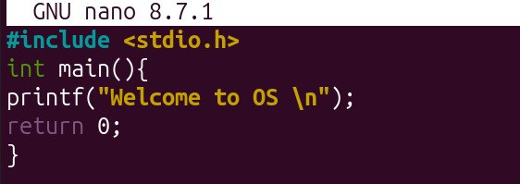
Output:
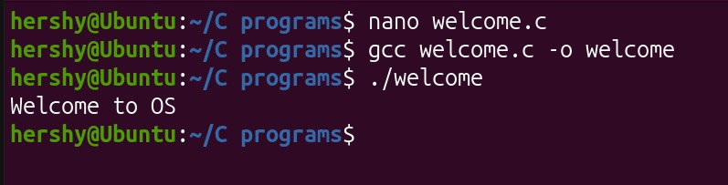
Program-2:
Code:
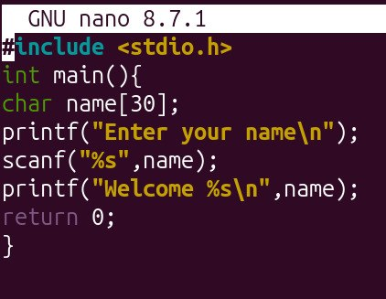
Output:
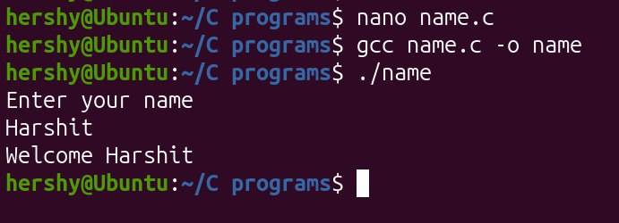

Program-3:
Code:
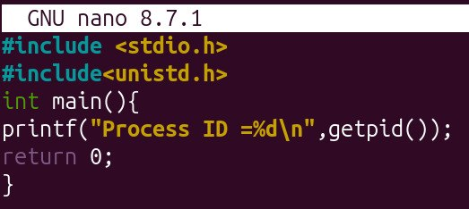
Output:


Program-4:
Code:
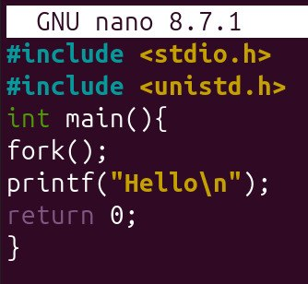
Output:
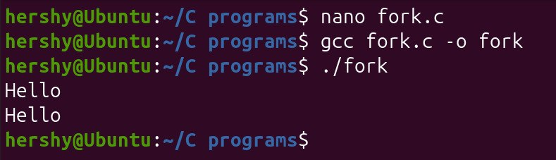

Program-5:
Code:
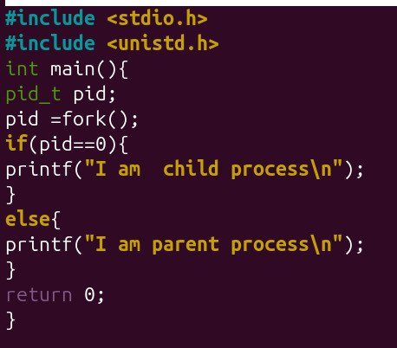
Output:
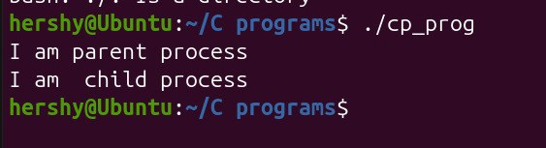

Program-6:
Code:
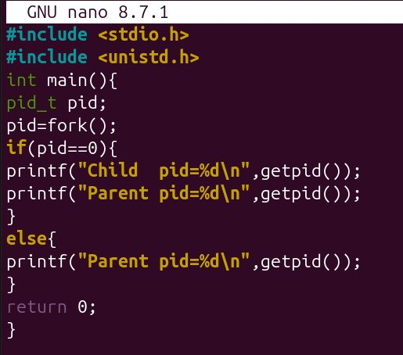
Output:
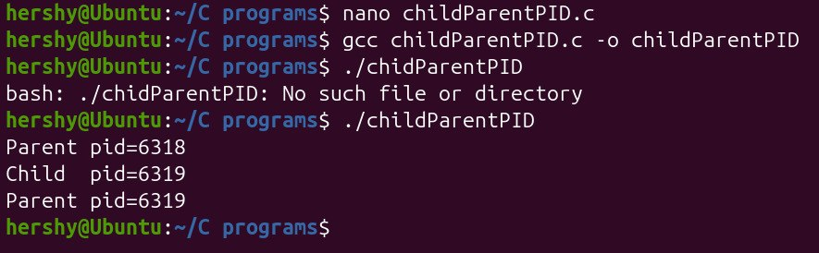
Program-7:
Code:
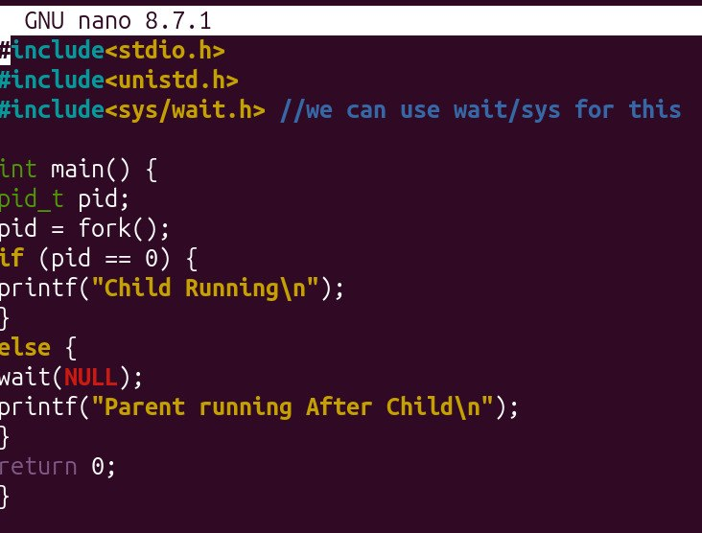
Output:
